Name | Peter Robertson
Course | ISW | Date | April 18th 2016
Title | Steve Jobs…….Task or People Focused? | Duration | 10 minutes

 | Time
Bridge-in | 30 seconds | Steve Jobs – Introduction and Background – Task Method vs People Method and discussion of Leader vs Manager discussion
Lesson Objective  Performance based  (ABCD) | 2 minutes | You will learn about Steve Jobs. There will also be an activity where you make the case for Steve Jobs – based on the discussion of Task vs People and Leader vs Manager……………………….Each team will contribute 3 examples in each area based on the information provided. Success will be evidenced by group activity, discussion and hands on learning and we will watch a brief video https://www.youtube.com/watch?v=K-Yv-UdsmSo
Pre-assessment | 1 minute | Task vs People – Manager vs Leader - discussion | Resources
Participatory Learning |  | Instructor and Learner Activities | Resources
Participatory Learning | 5 minute | Completion of Group Activity – 3 Examples of each from materials provided today and your personal experience with what you know about Steve Jobs - each group summarizes – 3 examples of each | PowerPoint and Handouts
Participatory Learning |  | Take away………………….. Materials and Case on Steve Jobs | Handout
Post-assessment | 30 seconds | Question and Answer session on what was learned – using Blackboard
Summary/ Closure | 1 minute | Today we learned about Steve Jobs, as it relates to leaderships task vs people and leader vs manager, completed a group activity………………where 3 examples of each were provided
Comments

Steve Jobs
Brief Bio - Information
Steven Paul "Steve" Jobs (February 24, 1955 – October 5, 2011) was an American information technology entrepreneur and inventor. He was the co-founder, chairman, and chief executive officer (CEO) of Apple Inc.; CEO and largest shareholder of Pixar Animation Studios;^{[3]} a member of The Walt Disney Company's board of directors following its acquisition of Pixar; and founder, chairman, and CEO of NeXT Inc. Jobs is widely recognized as a pioneer of the microcomputer revolution of the 1970s, along with Apple co-founder Steve Wozniak. Shortly after his death, Jobs's official biographer, Walter Isaacson, described him as a "creative entrepreneur whose passion for perfection and ferocious drive revolutionized six industries: personal computers, animated movies, music, phones, tablet computing, and digital publishing."^{[2]}
Jobs's countercultural lifestyle and philosophy was a product of the time and place of his upbringing. Jobs was adopted at birth in San Francisco, and raised in a hotbed of counterculture, the San Francisco Bay Area during the 1960s.^{[4]} As a senior at Homestead High School in Cupertino, California, his two closest friends were the older engineering student (and Homestead High alumnus) Wozniak and his girlfriend, the artistically inclined and countercultural Homestead High junior Chrisann Brennan.^{[5]} Jobs and Wozniak bonded over their mutual fascination with Jobs's musical idol Bob Dylan, discussing his lyrics and collecting bootleg reel-to-reel tapes of Dylan's concerts.^{[6]} Jobs later dated Joan Baez who notably had a prior relationship with Dylan.^{[6]} Jobs briefly attended Reed College in 1972 before dropping out.^{[5]} He then decided to travel through India in 1974 and to study Zen Buddhism.^{[7]}
The duo started in the Jobs family garage, funding their entrepreneurial venture by Jobs selling his Volkswagen bus and Wozniak selling his beloved scientific calculator.

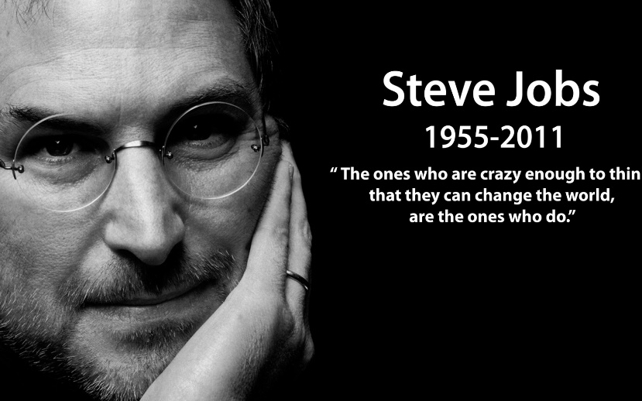
Steve Jobs – Top 10 Rules for Success
1. Don’t live a limited life
2. Have passion
3. Design for yourself
4. Don’t sell crap
5. Build a great team
6. Don’t do it for the money
7. Be proud of your products
8. Build around your customers
9. Marketing is about values
10. Stay hungry, stay foolish

Extra Materials
Last day of my life………… https://www.youtube.com/watch?v=KvA_4YkGNXc Stanford Speech

https://www.youtube.com/watch?v=eHzAtxW3TzY

