

Assignment #4

23 – DIRECT PARAPHRASING

  - Informal Classroom Assessment Techniques
Peter Robertson | PIDP 3230 | March 15th 2019

23 – Direct Paraphrasing

WHY DID I PICK THIS PARTICULAR CAT?
- I picked this CAT for MR2700 International Marketing class where we talk about what many issues related to International Marketing and need to translate many topics into simple language that others can understand or relate to and again it starts a great dialogue around International Marketing.

Brief description of the cat
Students will research and present information on the various topics in International Marketing in their own words. They will then present a PowerPoint to the class on what they read and understand. I have used this technique many times but called my exercise “Edutainment”.
Step By Step
1) The students will select a important theory, concept or argument that students have studied in depth that has some implications outside the classroom. 1
2) Determine who would be a realistic yet challenging audience for a paraphrasing of the topic; what the purpose would be and how long – in words, slides or time. If they feel comfortable with the material you could get them to address two different audiences. 1
3) Try responding to the Directed Paraphrase yourself to see how realistic the assignment is. Can you write and effective paraphrase within the limits given? .1
4) Direct the students to prepare a paraphrase of the chosen topic. Tell them who the intended audience is, what the purpose is, and what the limits are on speaking time or the number or words or sentences. Let them know how long they will have to respond to the assessment. 1

purpose of the cat
This Directed Paraphrasing technique assesses the student’s ability to translate the learning into a form that someone outside the classroom can understand and directed at an audience that can understand it which makes the task more demanding and more useful than simple paraphrasing. 1 The activity helps me understand their perspective on the topic as well as helps students with assessing their own viewpoint of the subject matter.
Ideas for adapting and extending this CAT include: 1
- Direct students to paraphrase the same topic for two different audience and then to explain the differences between the two paraphrase. 1
- Ask students to keep a journal of paraphrases as a summary of important topics in the course.
- Have different students paraphrase different reading assignments or lectures and ask them to share with the other members of their study group or with the rest of the class. 1
- Get an appropriate outside “expert” to comment on or assess some or all the feedback to the students or have the student’s role play the parts of an expert reader. 1
Once the directed paraphrasing has been collected you can separate the responses into four piles, which might be labelled “Confused”, “Minimal”, “Adequate” and “Excellent”. Then you can compare responses within and across categories. Pay attention to 1) the accuracy of the paraphrase 2) the suitability for the intended audience 3) and the effectiveness in fulfilling the assign=ed purpose. Another approach is simply to circle the clearest and muddiest points in each paraphrase and then look to common patterns of clarity and confusion. 1

what are the pros of conducting this cat?
Direct Paraphrasing builds n and builds up the student’s skills in actively and purposefully comprehending and communicating information learned in the course. 1
This technique can provide Faculty to find out quickly and, in some detail, how well students have understood a given lecture or segment of the course which can help instruction and the syllabus.1
It forces teachers and students to consider the wider relevance of the subject being studied and the importance of considering the needs of the audience as well as their interest.

what are the disadvantages of this cat?
Unless there are some strict length limits this could take too much time as they do take time and effort to do a Direct Paraphrase. 1
It is difficult to establish qualitative criteria for a good paraphrase and also to make the criteria explicit to the students. 1
The paraphrasing skills make not improve for some student unless there is focused, individual feedback that again may take time. 1
CAVEATS
1) structure it and plan it 2) won’t look like their own words the first time 3) use this CAT more than once in the semester so student and instructor can learn from the process. 1

how i will use this cat to provide feedback to the student?
Through classroom discussion and maybe privately depending on the situation.

an example of how i will use this cat?
Early in the semester as an icebreaker in the Introduction to International Marketing.

QUESTIONS FOR YOU?
- How can you use this strategy?
- What did you learn from the experience?
- What did I do that helped you learn?
===============================+++=====================================
The project presentation for this course requires you to select a topic, chapter, idea from the course and present it to the class in your own words. Note the audience will be given to you.
You may present your International Marketing topic.
- Individually (3 – 5 minutes), or
- Work in groups up to a maximum of 3 students 7 – 10 minutes
- PowerPoint to be uploaded to D2L Dropbox
- Entrepreneurs cannot be duplicated. You must check with your instructor to ensure that no one else has selected the same entrepreneur.
- First come, first served
- The content must be in your own words
- You must be in attendance on the day of the presentation to receive a mark

Your PowerPoint presentation must include as a minimum:

- Title Slide
- Objective slide
- The Topic
  - Details of Topic
- Question and answer slide
- Summary Slide
- Bibliography
- Other
For the PowerPoint
- Use Smart Art where possible
- Remember the 6 x 6 rule
- Use professional Transitions and Animations
- Reference your information
- Use professional background design
- Add more “quality extras” information slides
- Font Size – body min 22
- ==================================================

SELF ASSESSMENT?

References
1 Thomas, A. Angelo, K. Patricia Cross 2nd Edition 1993 Classroom Assessment Techniques – A Handbook for College Teachers Jossey Bass A Wiley Company Pages 232-235

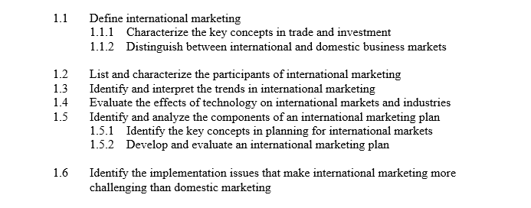
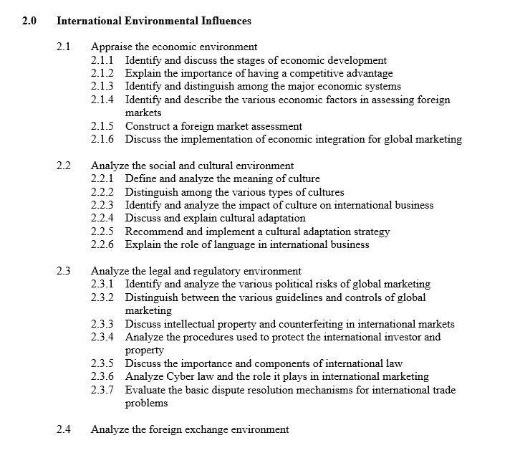

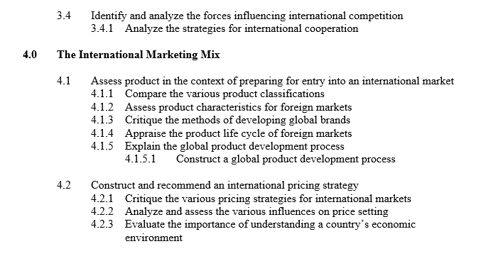

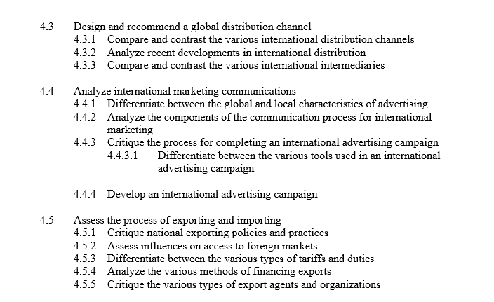

Week | Topic | Chapter | Assessment
Week 1  Jan. 6 | Introductions  Scope and Challenge of International Marketing | 1
Week 2  Jan. 13 | – Scope and Challenge (cont’d)  – Economic Environment | 2 | Edutainment 1
Week 3  Jan. 20 | - Economic Environment (cont’d)  - Social and Cultural Environment | 4 and 5 | Edutainment 2
Week 4  Jan. 27 | - Social and Cultural Environment (cont’d)  -Legal and Regulatory Environment | 6 and 7 | Edutainment 3
Week 5  Feb. 3 | -Legal and Regulatory Environment (cont’d) | 6 and 7 | Application Assignment (20%) (February 11, 2019)  Edutainment 4
Week 6  Feb. 10 | – The Foreign Exchange Environment  February 12th Sports Day Holiday | Foreign Exchange PPT | Edutainment 5
Week 7  Feb. 17 | – The International Marketing Research Process  Mid-Term - Feb 18 | 9 and 10 | Midterm (25%) (February 18, 2019)  Edutainment 6
Week 8  Feb. 24 | - International Market Segmentation | 9 and 10 | Edutainment 7
Week 9  Mar. 3 | – Foreign Market Entry Strategy | 11 | Edutainment 8
Week 10  Mar 10 | Foreign Market Entry Strategy (cont’d)  Forces of International Competition and Cooperation | 12 | Edutainment 9
Week 11  Mar. 17 | – Assessing Product in Preparing for Market Entry | 13 and 14 | Edutainment 10
Week 12  Mar. 24 | - Assessing International Pricing Strategy – Assessing International Distribution Strategy | 15 and 18 | International Marketing Plan  (Due Date Sunday March 25, 2019)  Edutainment 11  Edutainment 12
Week 13 Mar 30 | – Assessing International Marketing Communications  - Exporting/Importing Practices | 16 | Edutainment 13  Edutainment 14
Final Exams  April 2-11 |  | Final Exam  (30%)
Course Delivery Schedule for MR2700 – Winter 2019

