Name | Peter Robertson
Course | PIDP 3210 – EP2150 | Date | September 27th 2016
Title | Entreprenurship | Duration | 100 minutes
Background – Week 2 – LO1

 | Time
Bridge-in  B | 5 minutes | Discuss what we learned last class and what we will discuss today – I always write on the board, check in and create a positive work environment for learning
Lesson Objective  Performance based  (ABCD)  O | 5 minutes | Welcome  See D2L - PowerPoint Chapter 1  - Define the role of the entrepreneur in.  - Describe the entrepreneurial profile and evaluate your potential as an entrepreneur.  - Describe the benefits and drawbacks of entrepreneurship.  - Explain the forces that are driving the growth in entrepreneurship.  - Explain the cultural diversity of entrepreneurship.  - Describe the important role small business plays in a nation’s economy.  - Put failure into the proper perspective.  - Explain how entrepreneurs can avoid becoming another failure statistic.  Today first we are going to take about…………………..
Pre-assessment  P | 5 minutes | What makes a good entrepreneur?  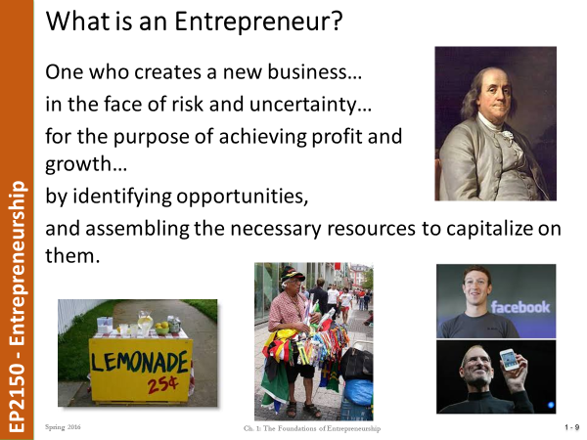 | Resources  White Board and Flip Charts
Participatory Learning  P |  | Instructor and Learner Activities | Resources
Participatory Learning  P | 20 minutes | Task – Answer the question? What makes a good entrepreneur?  Be prepared to present your findings to the class – you can use the Internet (Computer equipped classroom) and Mobile phones. | White Board and Flip Charts and Computers and Mobiles
Participatory Learning  P | 10 minutes | Presentation of their thoughts…… | White Board and Flip Charts and Computers and Mobiles
Participatory Learning  P | 15 minutes | 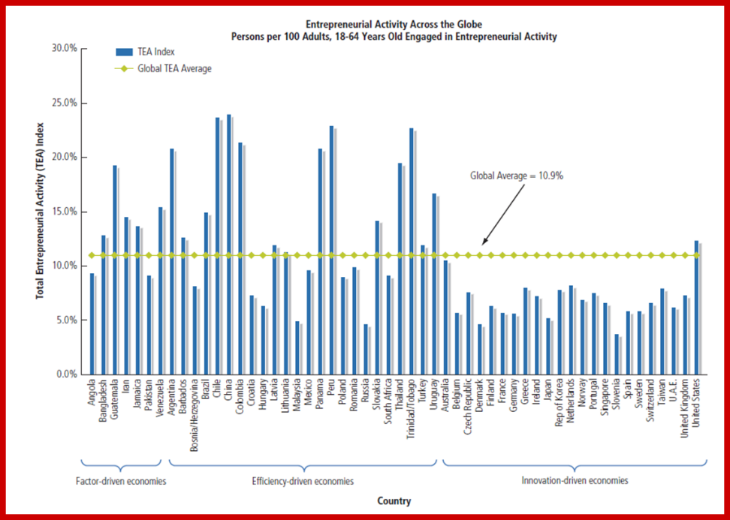Classroom discussion and activity – Why do you think of this survey and the GEDI chart below? Why ?  Spend some time discussing in your groups. Qatar 2030  - Entrepreneurship and the 2030 Vision:  - From Carbon based to Knowledge based  - 20,000+ SME’s  - Enterprise Qatar - 100m QR Investment Fund  - Q Business Incubator Center – QDB & SDC  - Establish an Entrepreneurial Eco-System.  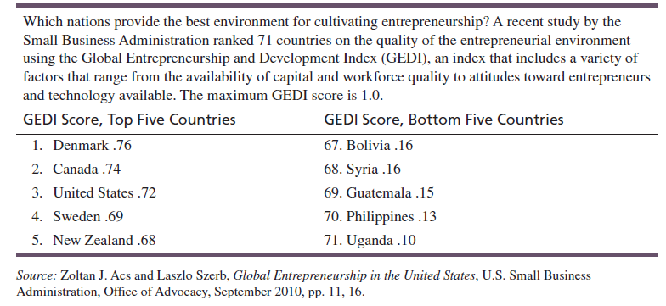 | Print out and display the chart.
 | 25 minutes | Presentation on Entrepreneurship and Entrepreneurs Characteristics includes - You Tube video  CLICK HERE FOR PRESENTATION | PowerPoint and Videos
Post-assessment  P | 10 minutes | Discussion on the presentation and what we discussed – ask the questions –  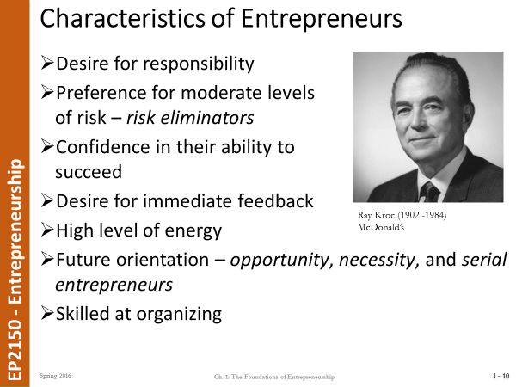  Entrepreneurs typically possess:  A) the ability to easily access capital.  B) a set of unique skills that is usually accompanied by advanced degrees in several areas.  C) a high level of commitment, have a tolerance for ambiguity, are flexible and tenacious.  D) specialized technical abilities.  Answer: C  Entrepreneurs are characterized by:  A) skill at organizing.  B) desire for immediate feedback.  C) high energy levels.  D) All of the above  Answer: D  Potential drawbacks of entrepreneurship may include:  A) uncertainty of income, risk, long hours, and high stress.  B) uncertainty of income, risk, easy hours, and frequent vacations.  C) uncertainty of income, risk, long hours, and the immediate accumulation of wealth.  D) certainty of income, risk, long hours, and high stress.  Answer: A
Summary/ Closure  S | 5 minutes | Please review Chapter 1 for the quiz next week. See D2L for materials.  Please get the book as you will need it for the Case that we will have next week as well.  Try and watch Jobs the movie (there are 2) if you have not seen it or look at some of the videos on Jobs on YouTube - there are lots of information online http://en.wikipedia.org/wiki/Steve_Jobs  Let me know if you have any questions  CLOSING - Ask how the students liked the exercises and lessons – ask them if they have any questions  Tell them to review the Slides on D2L and do the T/F and M/C on the publisher web site
Comments and Rational |  | Good balance of participatory learning and lecturing – some good multi-media content.

