Doha – Things To Do

An Epic Virtual Field Trip

1 Souq Waqif - Haggle your way around Souq Waqif
Busy, bustling and vibrant, this is one of the most Qatari experiences you can have in the city. Although the souq was rebuilt in the last decade or so, it sits on the original site of a Bedouin market, so the stone and wooden shops are still authentic and atmospheric. Pick up classic tourist souvenirs – keyrings, magnets, spices – as well as colourful embroidered throws, pillows, soft Turkish towels (peshtemals), ouds, oils and pretty much anything else you can think of. Thursday nights are liveliest and most of the squares will have food carts set up selling traditional snacks from across the Arab world. Alternatively, dine on the rooftop of Tajine (4435 5554) for a fun, casual Moroccan meal, with Arabic films projected onto the wall.
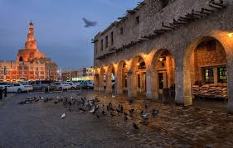
2 MIA. Wander around the Museum of Islamic Art
From the outside, the Museum of Islamic Art (4422 4444) is one of the most iconic buildings in the city. And inside it’s just as impressive. The main atrium offers spectacular West Bay views through three storey high windows and the museum’s permanent exhibitions display beautiful objects from across the Islamic world – everything from metalwork, ceramics and textiles to manuscripts – that date as far back as the 9th Century. It’s worth taking advantage of one of the free tours (Wed-Thu, 2pm; Sat 4pm), and then round off the day with a stroll around the beautiful MIA Park.
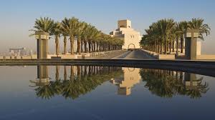
3 Dune-bash your way to the inland sea
Ask anyone in Doha for a list of must-visit sights, and Khor Al Adaid – otherwise called the Inland Sea – will invariably make an appearance. The huge inlet of water is surrounded by giant rolling dunes and can only be reached by driving off-road. You can sign up for full-day, half-day and overnight tours with various companies, but we’d recommend simply packing lots of food, taking a tent and heading out in convoy with a group of friends (preferably with someone who’s somewhat familiar with the route). Don’t forget to take ample get-out-of-the-sand supplies like a strong tow rope, shovels and boards.
To get there, use GPS co-ordinates: 24°42’50”N, 51°24’55”E.
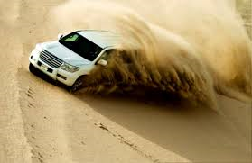
4 Sheikh Faisal - See prehistoric remains
Sheikh Faisal bin Qassim Al Thani’s collection of antiques and art must be one of the most enviable in the world. Since the 1960s, Sheikh Faisal has curated a staggering collection of art, ceramics, cars, religious texts and more, and there’s somewhere around 3,000 objects on display over five huge halls in his museum at Al Samriya. You’ll come across mannequins dressed in traditional bridal outfits, 18th century Yemeni douqas (a type of amulet worn around the neck with a handwritten religious citation), 17th century Iranian swords, rusty bicycles, vintage cars, and far more besides. Perhaps most impressive are the fossils, including the head and neck of a Plesiosaurus found in the depths of the Sahara desert, dating back somewhere around 120 million years. Advance appointments are required. The museum is located in Al Samriya, 22km west of Doha. The museum is half an hour by car from central Doha. Take Dukhan road away from Doha and head to Shahaniya and Dukhan. Turn off at the sign for the Camel Racetrack. Go all the way around the roundabout and back on to Dukhan Road heading towards Doha, effectively making a U-turn. Then take the fourth exit signposted Al-Samriya, Sheikh Faisal Bin Qassim Al Thani Museum. Free. www.fbqmuseum.com. http://www.fbqmuseum.org/
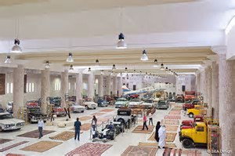
5 Spend a long weekend at Banana Island Resort
Stepping off the boat here makes it hard to believe that you were in Doha just 25 minutes before. The golden curve of sand, tipped with over-water villas, is quiet and serene (though there are more affordable standard rooms, too). Even at full capacity, the beach is almost empty, so no matter when you visit you’re in for a relaxing trip, plus there’s a surfing simulator, a bowling alley, cinema, eight restaurants and cafés, a huge wellness centre, and one of the best hammams we’ve seen in Doha. It’s the perfect place to “get away from it all”.
www.doha.anantara.com (4040 5050).
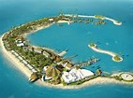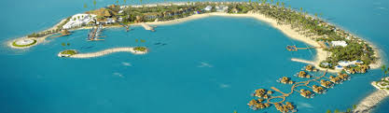
6 Katara. Hunt down the city’s best Karak
Katara is amazing. So much to do here. See the mosque and the Amphitheatre. And there’s nothing better than sitting down to watch the world go by with a nice hot cup of sweet, creamy karak chai. The best cups can be found in the unlikeliest of places – a tiny roadside café, or a petrol station en-route to Fuwairat. The most accessible (and very tasty) is available at homegrown Chapati & Karak in Katara Cultural Village (www.katara.net). It will be far cheaper and much more enjoyable than a daily Starbucks.
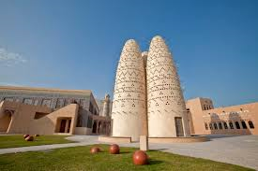
7 Corniche. Walk, run or cycle along the Corniche
Don’t underestimate the length of the Corniche, as it’s seven kilometres in total, dotted with examples of public street art and boasting lovely views of West Bay. Make the time to wander along at least part of it. Or, you could just sit to admire the view from Al Mourjan (4483 4423) while enjoying some excellent Lebanese food.
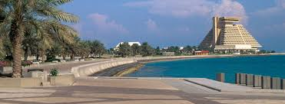
8 Brunch. Hit a blow-out brunch
There’s Qatari tradition and there’s expat tradition. Brunch is probably the most expat custom you can possibly partake in and if you want to really go all out, head to The St. Regis Grand brunch (4446 0000) for a spread so big that your place mat doubles as a map of all the food stations – everything from foie gras and sushi to chilli dogs and fish and chips (plus a fair few themed beverage stations). Book in advance to bag a table on the terrace where live music is provided by Jazz at Lincoln Centre Doha.
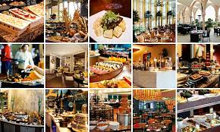
9 Kayak through the mangroves
Entalek (www.entalek.org) organises tours to the mangroves at Al Thikira Bay, with a few two-hour options that include fascinating talks about the mangrove ecosystem and a pit-stop at a secluded mangrove beach for a barbecue. You can sometimes spot flamingos in shallow spots, as well as reef egrets, terns, herons and jumping fish, while hermit crabs can be seen scuttling in the shallows around the beach. The more intrepid, however, should book one of the private overnight trips with Aquasports (www.aquasportsqatar.com), which stop off to camp under a bright starry night at an isolated spot that’s otherwise difficult to reach by land.
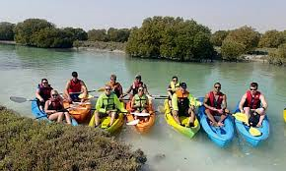
10……………and then dine at IDAM by Alain Ducasse
If you love food, IDAM by Alain Ducasse in the Museum of Islamic Art (4422 4488) is probably the single most not-to-be-missed experience in Doha. Is it expensive? Extremely. Is there anything else like it in the city? Definitely not. A meal here delivers surprise after surprise, whether it’s the addition of chestnuts to the homemade pasta with celery and pumpkin or the myriad of textures in the “confit tanger” dessert (sweet jam and tart grapefruit granitas are just two). The food is a wonderful fusion of European and Arabian and there’s a huge list of clever and refined mocktails, served in futuristic glasses. All served in the grandest of settings – suspended above the museum’s atrium.
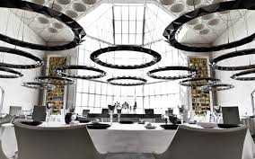
11 Shop for antiques at the very quirky Shanzelize Palace
Formerly called Champs Élysées, this antiques shop is hilariously un-selective about its stock. There’s a section dedicated to crockery featuring the British royal family, Coca Cola memorabilia, piles of old letters and photographs from across the world, mixed in with gramophones, Nokia 3310s, old Quality Street tins, taxidermy (including, once, a sting ray), rusty keys, collectible stamps, ancient cameras and so, so much more. Anything goes.
Next to Thai Snack (no number).
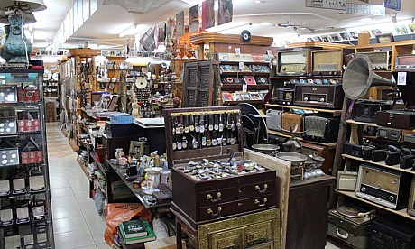
12 Party at Illusion
Doha’s newest nightlife venue is also its biggest and the fairy-light strewn rooftop terrace is without doubt one of the most pleasant places for a night out. With a menu of mixed beverages and panoramic views over The Pearl, it’s the perfect spot for a quiet weekend drink. Afterwards, book a table at its second nightlife venue, 1933 – The Grand Hall, which is open Thursdays and Fridays, complete with a huge psychedelic dome, aerial performance artists and dance music from the resident DJs. For reservations, contact reservations@illusiondoha.com (4035 5757).
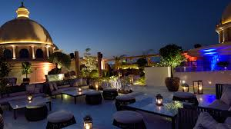
13 Eat at Doha’s budget institutions
There’s no shortage of fine dining, break-the-bank restaurants in Doha, but you can get just as good a meal – if not sometimes a better one – along Mirqab Al Jadeed Street. The succulent kebabs at Turkey Central (4443 2927) are popular for good reason, while the quirky setting of Thai Snack’s (4432 9704) little courtyard is the only thing that comes close to outshining its famously authentic food.
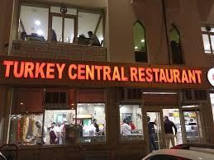
14 Eat and drink with a view
Is there any better kind of sundowner than a sundowner with a view? For the best view in Doha, take your pick of Strata Lounge at InterContinental Doha The City (4015 8888), with its futuristic blue and pink lighting, or the new Z Lounge by Zengo at Kempinski Residences & Suites (4405 3561). Both are located on top floors in looming towers in West Bay and offer incredible panoramic views across the whole city, while Z Lounge in particular has a great selection of Latin-Japanese bar bites and mixed beverages.
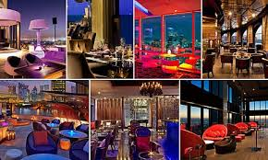
15 Have a musical night at Jazz at Lincoln Centre
Without a doubt one of the coolest venues in the city, head to The St. Regis and spend an evening at the Doha outpost of famed New York institution Jazz at Lincoln Centre Doha (4446 0105). It showcases some of the most talented names in jazz music and soul food, so settle back on a cosy sofa and some Louisiana shrimp for one of the best nights out in the city.
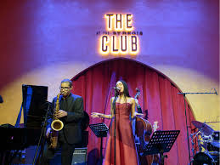
16 Eat your way around Doha’s best mezzes
If there’s one thing Doha does well, it’s Middle Eastern food (go figure). Qatari, Lebanese, Turkish, Moroccan, Iranian; Doha has it all, but there are a few spots that are must-visits. Damasca One (4475 9088) is arguably one of Souq Waqif’s most popular restaurants, with fantastic food, but the elaborate, mirrored interiors of Parisa (4441 1494) in the souq are second to none. On The Pearl, Debs W Remman (4456 8374) serves excellent Lebanese fare (try the halawe mchalale dessert – it’s essentially a candy floss sandwich) in an eclectic setting that’s reminiscent of Beirut's quirky cafés. Or, head to Al Mourjan (4483 4423) on the Corniche for stunning West Bay views and a lively atmosphere. For a more upmarket affair, Al Sufra (4035 5011) in the Marsa Malaz Kempinski is beautifully-designed and contemporary, serving Levantine cuisine.
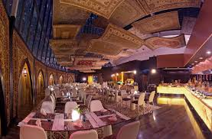
17 Pamper yourself at Sharq Village
Six Senses Spas are renowned around the world for good reason. They offer some of the most relaxing settings you’re likely to find and the 6,500-square metre spa at Sharq Village & Spa (4425 6666) is one of the biggest in the region. It's designed to look like a Middle Eastern village, with winding alleyways and water features. And the menu covers more than 250 treatments from Arabian, Thai or Swedish therapies to holistic options.
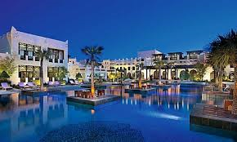
18 Get lost in Film City
Film City is a strange, deserted film set in the middle of the desert near Zekreet that was built to look like a traditional Qatari village. There’s not really much to do except wander around taking pictures, but the friendly caretakers are always happy to chat, and the place is odd enough to warrant a visit at least once. You’ll need a four-wheel drive and be warned that the “city” isn’t well signposted, so it’s easy to get lost. Follow signs to Dukhan on the Dukhan Highway, turn right onto a graded desert track near signs to Zekreet and follow it to the city.
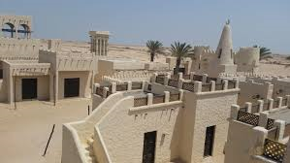
19 Write-off a whole Friday
Head to the Grand Hyatt (4448 1234) to make a whole day and night of brunch. The Grill serves up an excellent international buffet of fresh seafood, pasta, roast meat, sushi, barbecue and more, and the brunch has a new theme almost every week (James Bond and Cuban, most recently). Afterwards, upstairs, the Liquid Brunch in Dunes has four hours of beverage deals, sing-along hits and popular club tracks. Head back down to The Grill at midnight, when the room in which you gorged on lobster just hours before will have been dramatically transformed into a club for A1 Nights. You’ll barely recognize the place.
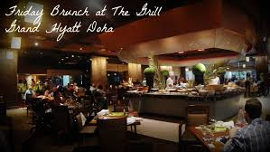
20 Dance along to the singing dunes
There are only around 30 places on the planet to hear this natural phenomenon, including here in Qatar. The sand “sings” – or, to describe it more accurately, it produces a variety of noises from bumps and thumps to hums, whistles and a haunting, moan-like sound. The natural curve of the dunes creates an amphitheatre for the sound of the grains of sand shifting against themselves. The sand has to be completely dry, and moving, so you'll have to run, jump and roll around a bit. Wrap a thick piece of cardboard in a bin-liner for a makeshift sled. Head out of the city on Salwa Road, and then head left, following signs to Mesaieed. Go straight through two roundabouts, then turn left at the next junction. Keep straight until you can see the dunes.
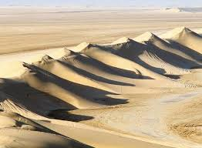
21 Spend a weekend at Sealine
Head here for crystal clear waters and a palm-fringed beach front. You can hop on a jet-ski, give flyboarding a go, play a few rounds of tennis, get a football game going, shoot some hoops, go dune bashing in the surrounding desert and even take a touristy camel ride. There are room, villa and chalet options for overnight stays, too. Rates aren’t the cheapest and it isn't five-star luxury, but it's worth it to get out of the city for a few days.
www.sealinebeachqatar.com.
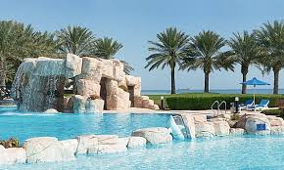
22 Camp along the coast
Qatar has numerous camping spots, but we think there are two that win out over the rest. Zekreet has unusual limestone cliff formations – also referred to as the white cliffs at Ras Abrouq – and a lovely series of little bays. Take Al Rayyan Road towards Dukhan. Exit at signs for Zekreet and head off right along a paved road to a small town. The road ends after an old mosque, but there will be a graded track to follow. Fuwairat has lovely sandy beaches and mangroves for camping by the sea (and where you can watch turtles hatching around the end of May). Take the Doha Expressway north out of the city, and continue for around an hour. Exit at the sign for Fuwairat.
Just before the town, a road leads left to the beach.
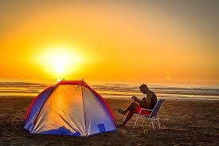
23 See desert giants
There are few things that can only be done in Qatar and seeing Richard Serra’s huge sculpture East-West / West-East standing in the desolate desert landscape of Qatar’s Brouq Nature Reserve is one of them. The four monoliths each have more than a kilometre between them and stretch across the nature reserve’s peninsula from one coast to the other. Each varies in height (the tallest is 16.7 metres high and the smallest 14.7 metres), but all of the monoliths are level to each other, as well as the tops of the gypsum plateaus on either side, which form a natural corridor. Standing beside these towering metal structures will make you feel as though you’re standing on an alien planet. Between Zekreet and Film City, you'll be able to spot them from the graded track.
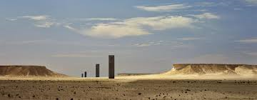
24 Dune bash on a quadbike in Mesaieed
Just by the turn-off to Sealine Beach Resort is a little cluster of shops where you can rent quadbikes for an hour or two and drive them over rolling dunes. This is a good option if you’re not keen to give dune bashing a go in your car, as pulling a small quadbike out of the sand is much easier than digging out a 4x4.
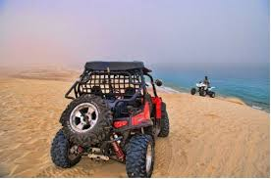
25 Ride a dhow
These are the traditional water vessels of the Gulf and there are dhow trips aplenty in Doha. There’s not much variety between them, except, perhaps, the quality of the food (even this is pretty standard across the board). Spend a leisurely day at sea, with Qatar International Adventures, relaxing with an on-board barbecue.
www.qia-qatar.com.
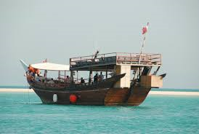
26 Attempt to learn Arabic
Arabic is a difficult language to learn. There’s a whole new alphabet to grapple with, for starters. But when in Rome, as they say – or in this case, Qatar – Fanar, Qatar Islamic Cultural Centre, offers a very affordable Arabic course for just QR300 that runs for two and a half months, twice a week. It’s one of the most comprehensive you can take, covering spoken Arabic, grammar and teaching you how to understand written Arabic, too. www.fanar.gov.qa.
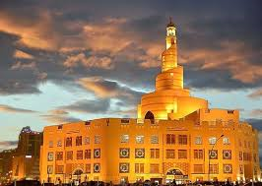
27 Picnic on Purple Island
Purple Island, also known as Jazirat Bin Ghannam, is surprisingly green, with a mangrove forest that’s teeming with small fish and crabs. Accessing the island requires a little scramble over a shallow stream of water, after which the rocky pathways lead around the island. There’s a little beach perfect for a picnic, so this is a lovely place to relax and enjoy a rare slice of lush nature in the desert. Drive to Al Khor and follow signs to Al Thakhira. Go past the turning for Al Khor community and go right at the RasGas roundabout. Continue to the sign for Flower Each Spring Camp and turn onto the dirt track. Go straight until you see a raised path on the right. If you reach the camp, you have gone too far.
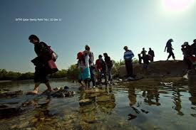
28 Go wild at a water park
Aquapark Qatar, located off Salwa Road, is small, but it’s a good place to cool off when the weather starts heating up. Attractions include adrenaline-inducing slides – like the 20 metre-high boomerango – a lazy river and wave pool, plus plenty of pools for kids. There’s a dress-code, so make sure you turn up with a T-shirt and pair of shorts that you’re happy to get wet.
www.aquaparkqatar.com.
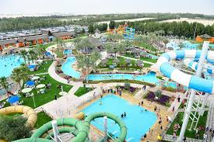
29 See robotic jockeys race on camels
Between November and February, Fridays are race days at Al Shahaniya Race Track. The practice of using children as jockeys was abandoned relatively recently in favour of robotic jockeys. It’s an interesting experience, particularly to see how Qatari traditions fit into the modern world.
Take the Doha-Dukhan road, and take the first exit from the roundabout after Al Rayyan football stadium. The race track will be signposted (4487 2028).
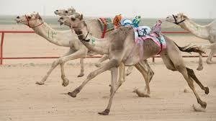
30 Get inspired by architecture at Education City
The upside to Education City? It’s full of stunning buildings and modern, space-age architecture. The Ceremonial Court (next to Northwestern University Qatar) is particularly instagram-worthy. The downside? It’s huge, so seeing it on foot isn’t much of an option. If you’re there, though, don’t miss stopping off at Chef’s Garden (Al Shaqab Hotel, 4409 5000) for a bite. The bulk of the menu uses vegetables produced locally – onsite and at a local organic farm – to make fresh and light dishes like zesty stuffed artichoke with beetroot cocoa biscuit.
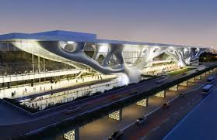

31 Watch a football match at Al Sadd Sports Club
Al Sadd is home to a great sports club and it’s where one of the world’s best footballers, Xavi Hernández, who was signed from Barcelona FC, plays. It’s definitely worth checking out a match there. www.al-saddclub.com.

32 Have tea and cake at Doha’s quirky cafés
Sugar & Spice (4411 4456) in Lagoona Mall is a particular favourite. It’s got an Alice in Wonderland vibe and much of the confectionary it sells wouldn’t be out of place at a Mad Hatter’s tea party. Expect whopping slices of cake and creations like sweet cookie casseroles. Yes please.
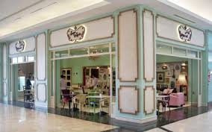
33 Track down Doha’s only food truck
Burgeri serves huge, juicy burgers from the city’s very first (vintage, school bus-style) food truck. Their location changes daily, but you can find out where they will be stationed by following @BurgeriDoha on Twitter. www.facebook.com/BurgeriDoha.

34 Indulge in High Tea
Another Qatari pastime is afternoon tea. Most hotels in the city serve it in one form or another (vintage themed, buffet-style, chocolate themed, golden). Some are more extravagant than others, but there are plenty of affordable options, too. For a traditional and refined afternoon, head to the Four Seasons (4494 8888), or, for something a little more quirky, W Café (4453 5135) where it’s served from a bird cage.
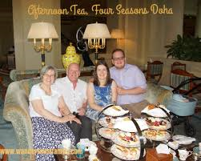
35 Splash out on gold
The rows upon rows of bright yellow, shimmering gold draped in shop windows are quite a sight. Even if you aren’t shopping, it’s worth visiting the Gold Souq to marvel at the hundreds of bangles and elaborate sets of wedding jewellery. If you are looking to buy, reputable shops will weigh it in front of you. Most shops also offer white gold, silver and platinum pieces for a range of (surprisingly affordable) prices.
Next to Al-Ghanim Central Bus Station, off Banks Street.
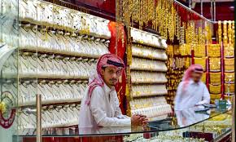
36 Take up a watersport
Make the most of living by the sea and spend your leisure time out on the water. Try them all and find the one you like best, whether that’s kayaking, stand-up paddleboarding, wake-boarding or even fishing. There are perfect spots along the whole coast of the city and beyond. Doha’s warm, calm conditions are ideal for learning to sail, and Regatta Sailing Academy (www.regattasailingacademy.com) offers five-week courses for beginners (suitable for both adults and kids) from their spot on Katara Beach.
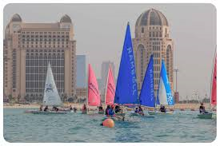
37 Dine at Doha’s best restaurant
Hakkasan at The St. Regis Doha (4446 0170) has now been awarded the prestigious Restaurant of the Year accolade at the annual Time Out Doha Restaurant Awards for an unprecedented two years running. It’s absolutely unbeatable in terms of everything, from setting and atmosphere to the fantastic bar and sensational contemporary Chinese cuisine. The fried dim sum platter is not to be missed, as is pretty much everything else on the menu.
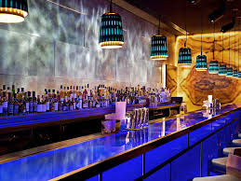

Other Choices
Bowling at Megapolis

Hit the Malls – more opening all the time – Mall of Qatar,,,,,,,,,,,,and now………………..Doha Festival City
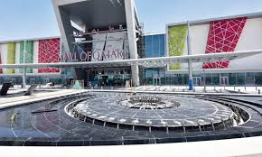
Eat on a Donut at the Diplomatic Club – BBQ
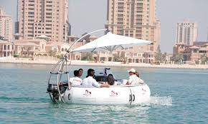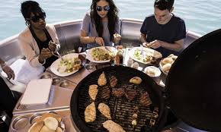
Hit the Spa – lots to choose from Jaula Spa at the Grand Hyatt for example
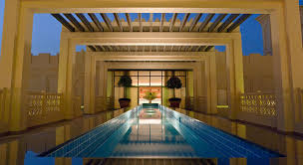 HAVE fun……………………………Mark and Peter
http://www.timeoutdoha.com/aroundtown/features/75821-best-things-to-do-in-doha

